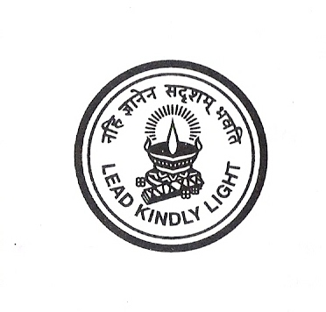

SRI KUMARAN CHILDRENS HOME, CBSE

CERTIFICATE

This is to certify that NAGABHARAN.N a student from class XI
has done his COMPUTER project at SRI KUMARAN CHILDRENS HOME, CBSE, from 2008 to 2009.

The project work entitled “STAR . WAVE” embodies the original work done by NAGABHARAN.N during his above academic year.

…………………………….
Teacher In-charge

……………………………… ……………………………
Examiner’s Signature Principal

Date: …………………… School Rubber Stamp

